Comparisons between book titles, Psalm inscriptions, Psalm 119 Hebrew letter inscriptions, and epistle colophons have been ommitted from comparision. The apocrypha has been ignored and omitted from comparisons.

All comparisons were done against the “Holy Bible King James Version (Entire Bible) Concord.txt” from truthischrist.com unless otherwise noted.

NOTE: There are also many seemingly trivial differences in capitalization (LORD’S or LORD’s), spelling (“i” or “e”), the formatting of Psalm 119 Hebrew letter superscriptions, and hyphenation (Elelohe-Israel or EleloheIsrael). The seemingly less trivial changes are documented below.

Pure Cambridge Edition checklist:
1. "or Sheba" not "and Sheba" in Joshua 19:2
2. "sin" not "sins" in 2 Chronicles 33:19
3. "Spirit of God" not "spirit of God" in Job 33:4
4. "whom ye" not "whom he" in Jeremiah 34:16
5. "Spirit of God" not "spirit of God" in Ezekiel 11:24
6. "flieth" not "fleeth" in Nahum 3:16
7. "Spirit" not "spirit" in Matthew 4:1
8. "further" not "farther" in Matthew 26:39
9. "bewrayeth" not "betrayeth" in Matthew 26:73
10. "Spirit" not "spirit" in Mark 1:12
11. "spirit" not "Spirit" in Acts 11:28
12. "spirit" not "Spirit" in 1 John 5:8

Source | File/edition name | Notes
Bibleanalyzer | av1769, av1769s | These two versions from the same app are not equal in the verse text. The av1769s has the extra “and” in Exo 23:23 and has some of the changes that appear in the PCE.
https://truthischrist.com/elton-anomaly-823543/ | Holy Bible King James Version (Entire Bible) Concord  Holy Bible Authorized Version (Entire Bible) PCE | The PCE version has all of the changes listed below in the right column and the Concord edition does not.  Concord:  - Romans 4:18  - “father of many nations;”
Crosswire.org | Crosswire King James Version: Pure Cambridge Edition  Version 2.0 (2022-09-28) (converted to sqlite using sword-converter 2.0.0) | - Many “LORD” changed to “Lord”.  - Many “GOD” changed to “God”.  - Extra “ THE” at the end of Ecc 12:14, Eze 48:35, Job 42:17, 1Thess 5:28.  - Extra “ THE END” at the end of Rev 22:21  - All of the changes in the table below (typical of the PCE)
Crosswire.org | King James Version (1769) with Strongs Numbers and Morphology and CatchWords  Version 3.1 (2023-07-19) | - First word of almost every verse capitalized.  - “JEHOVAH” changed to “Jehovah”  - Job 31:1 “I MADE” insead of “I made”  - Gen 2:9 Comma removed after “sight”  - Joshua 19:2 “or” removed from before “Sheba”  - Gen 1:2 Missing comma after “form”  - Exo 17:15 “JEHOVAH-nissi” instead of “Jehovah-nissi”
eBible.org | King James (Authorized) Version eng-kjv2006_readaloud.zip (Plain text canon only chapter files) v28.2 | - First word of almost every verse capitalized.  - Gen 25:4  - “Abidah” instead of “Abida”  - Gen 42:56  - “and Joseph” instead of “And Joseph”  - Acts 4:20  - “can not” instead of “cannot”  - Col 3:17,23  - “what soever” instead of “whatsoever”  - 1Ti 2:7  - “Where unto” instead of “Whereunto”  - 1Ti 5:25  - “can not” instead of “cannot”  - 1Ti 6:12  - “where unto” instead of “whereunto”  - 2Ti 1:11  - “Where unto” instead of “Whereunto”  - 2Ti 2:9  - “Where in” instead of “Wherein”  - 2Ti 2:13  - “can not” instead of “cannot”  - Hebrews 6:17  - “Where in” instead of “Wherein”  - Hebrews 9:5  - “can not” instead of “cannot”  - 1 John 2:23  - “but” instead of “(but)”
eBible.org | KJV Cambridge Paragraph Bible v9.27 | - Many beginning-of-verse words lowercased instead of capitalized  - Extremely large amount of word spelling changes (some of which could change interpretation and doctrine; only some are listed)  - Extremely large amount of punctuation changes.  - Many “ye” changed to ambiguous “you”  - Gen 19:21  - “also” removed after “concerning this thing”  - Exod 29:26  - “consecrations” instead of “consecration”  - Num 17:8  - “witness; and, behold,” changed to “Witness; and behold,”  - Num 29:39  - “besides” instead of “beside”  - Psalm 119 Hebrew inscriptions are written in Hebrew instead of English  - Judges 11:29  - “Spirit” changed to “spirit”  - Judges 21:11  - “lain” changed to “lien”  - Completely different definition  - 1 Samuel 16:13  - “Spirit” changed to “spirit”  - 2 Samuel 3:31  - “Rend” changed to “Rent”  - 1 Kings 9:22  - “bondmen” changed to “bondman”  - 1 Kings 9:28  - “fetched” changed to “fet”  - 1 Chronicles 7:5  - “valiant” removed from after “Issachar were”  - Isaiah 34:14  - “screech owl” changed to “shrich owl”  - Ezekiel 43:27  - “eighth day” changed to “eight day”  - Ezekiel 44:29  - “dedicated” changed to “dedicate”  - Daniel 2:27  - “astrologers” changed to “astrologians”  - Hosea 14:7  - “the scent” changed to “The sent”  - Zechariah 2:1  - “I lifted” changed to “I lift”  - Malachi 3:2  - “fullers’ soap” changed to “fullers’ sope”  - Matthew 14:30  - “boisterous” changed to “boysterous”  - Matthew 19:26  - “impossible” changed to “unpossible”  - Luke 13:12  - “thine infirmity” changed to “thy infirmity”  - Acts 10:19  - “Spirit” changed to “spirit”  - Acts 11:28  - “Spirit” changed to “spirit”  - 1 Timothy 2:9  - “shamefacedness” changed to “shamefastness”  - Revelation 6:14  - “scroll” changed to “scrole”  - Revelation 11:11  - “an half the Spirit” changed to “a half the spirit”  - 1 John 5:8  - “Spirit” instead of “spirit” (compared to the PCE)
eBible.org | King James Version + Apocrypha engKJV1769eb v67.2 | - 6x “cannot” changed to “can not”  - Gen 25:4  - “Abida” changed to “Abidah”  - 1Ch 1:33 “Abida” not changed  - “instructors” changed to “instructers“  - 2x “whatsoever” changed to “what soever”  - 2x “Whereunto” changed to “Where unto”  - 1x “whereunto” changed to “where unto”  - 2x “Wherein” changed to “Where in”  - 1 John 2:23  - “(but)” changed to “[but]”
Project Gutenberg | The King James Version of the Bible  Release date: August 1, 1989 [eBook #10]  Most recently updated: October 29, 2024 | - Many spelling and punctuation changes  - “ye” changed to ambiguous “you”  - Gen 5:3  - “and” added before “after his image”  - Gen 6:16  - “thy maid is in thy hand” changed to “thy maid is in thine hand”  - Exodus 25:34  - “candlestick” changed to “candlesticks”  - Leviticus 26:11  - “And I will set my tabernacle” changed to “And I set my tabernacle”  - Joshua 13:14  - “tribe of Levi” changed to “tribes of Levi”  - Nehemiah 9:28  - “hand of their enemies” changed to “land of their enemies”  - Job 33:4  - “Spirit of God” changed to “spirit of God”  - Psalm 32:5  - “I acknowledged” changed to “I acknowledge”  - Matthew 4:1  - “Spirit” changed to “spirit”  - Many “Son of David” (referring to Jesus) changed to “son of David”  - Mark 1:2  - “Spirit” changed to “spirit”  - Mark 15:2  - “said unto him” changed to “said unto them”  - Acts 13:22  - “he gave testimony” changed to “he gave their testimony”  - 1 John 2:23  - “(but)” removed  - Revelation 11:11  - “Spirit of life” changed to “spirit of life”
OpenBible.com | Pure Cambridge edition (text courtest of www.BibleProtector.com) | - Has all the typical PCE changed in the right column below
Archive.org  (https://archive.org/details/kjv-text-files) | TXT files of the King James Version of the Holy Bible  2021-12-27 20:39:55 | - 1 Samuel 6:9  - “that smote us:” instead of “that smote us;”  - Appears to be correct, and the Concord has the wrong character  - 1 Chronicles 2:47  - “Gesham” instead of “Geshan”  - 1 Chronicles 2:49  - “Achsa” instead of “Achsah”  - 1 Chronicles 7:19  - “Shemida” instead of “Shemida”  - 2 Chronicles 2:16  - “flotes” instead of “floats”  - Jeremiah 2:22  - “sope” instead of “soap”  - Malachi 3:2  - “sope instead of “soap”  - Romans 4:18  - “nations,” instead of “nations;”  - Appears to be correct, and the Concord has the wrong character  - 1 John 2:23  - “but” instead of “(but)”
Keith Gibson | Old printed Bible “Holy Bible” (1,838m 1925) American Bible Society KJV | - Exo 23:23  - “Angel”  - No extra “and”  - 1 John 5:8  - “spirit”  - Acts 11:28  - “Spirit”  - Acts 21:4  - “Spirit”  - Matthew 4:1, Mark 1:12, Luke 4:1  - “Spirit”
Keith Gibson | Old printed Bible  Thomas Nelson 1970 Holy Bible KJV | - Exo 23:23  - “Angel”  - No extra “and”  - 1 John 5:8  - “spirit”  - Acts 11:28  - “spirit”  - Acts 21:4  - “Spirit”  - Matthew 4:1, Mark 1:12  - “spirit”  - Luke 4:1  - “Spirit”
Holy-bible.online | KJV | - Jos 19:19  - “Haphraim”  - 1Sa 6:9  - “his hand that smote us:”  - 1Ch 2:47  - “Gesham”  - 1Ch 2:49  - “Achsa”  - 1Ch 7:19 (Num 26:32, Jos 17:2: Shemida)  - “Shemidah”  - 2Ch 2:16 (1Ki 5:9: floats)  - “flotes”  - Jer 2:22, Mal 3:2  - “sope”
E-Sword app | Included KJV  King James Version  This is the 1769 King James Version of the Holy Bible (also known as the Authorized Version).  Published in 1769; public domain. | - 1Sa 6:9  - “Bethshemesh”  - “that smote us:”  - Rom 4:18  - “many nations,”  - Almost exactly the same as Bibleanalyzer av1769
Ccel.org | HOLY BIBLE  King James Version  PDF | - Very large amount of spelling, punctuation, and formatting changes.  - Numerous word changes (that don’t seem to make any sense. Bad scan?)  - Genesis 26:18  - “philistines”  - Gen 30:3  - “and she shall bear upon my knees that” instead of “and she shall bear upon my knees, that”  - 2Ki 5:15  - “there is no God in earth, but in Israel:” instead of “there is no God in all the earth, but in Israel:”  - 1Ch 7:9  - “heads of the house of the fathers,” instead of “heads of the house of their fathers,”  - 1Ch 11:11  - “and Hachmonite,” instead of “an Hachmonite,”  - 1Ch 12:6  - “PrAzareel” instead of “Azareel”  - This word change appears at least 4 times  - 2Sa 8:16  - “And Joab the son Zeruiah” instead of “And Joab the son of Zeruiah”  - 2Ch 2:16  - “flotes” and “thou shall carry” (instead of shalt)  - Ezra 8:15  - “the river than runneth to Ahava;” instead of “the river that runneth to Ahava;”  - Neh 3:14  - “part of Beth-haccerem; he build it,” instead of “part of Bethhaccerem; he built it,”  - Several “O” changed to “Oh”  - Job 30:6  - “cliffs” instead of “clifts”  - Psa 17:4  - “Concerning the words of men,” instead of “Concerning the works of men,”  - Pro 6:3  - “Do this now, my son, deliver thyself,” instead of “Do this now, my son, and deliver thyself,”  - Jer 32:5  - “?” at the end instead of “.”  - Jer 2:22, Mal 3:2  - “sope” instead of “soap” (2x)  - Jer 33:5  - “but it is fill them with the dead bodies of men,” instead of “but it is to fill them with the dead bodies of men,”  - Jer 36:2  - “even into this day.” instead of “even unto this day.”  - Acts 11:12,28, 1John 5:8  - “spirit”  - Rev 2:6,15  - “Nicolaitanes” instead of “Nicolaitans”  - Rev 19:16  - “King of Kings, and Lord of Lords.” instead of “KING OF KINGS, AND LORD OF LORDS.”
Archive.org | KJV 1769 Oxford edition  PDF scan of the printed book | - Exodus 23:23  - Capital “A”, No extra “and”  - Matthew 4:1  - “spirit”  - 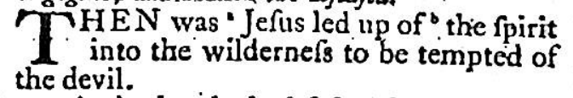  - Mark 1:12  - “spirit”  - 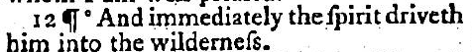  - Luke 4:1  - “Spirit”  - 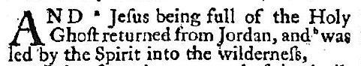  - Acts 11:12  - “spirit”  - 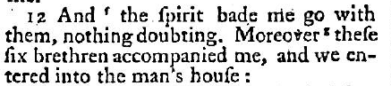  - Acts 11:28  - “spirit”  - 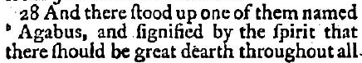  - 1 John 5:8  - “spirit”  They didn’t have any problem printing a capital “S” in Mat 4:3 so Mat 4:1, Mar 1:12, and 1 John 5:8 were intentional:  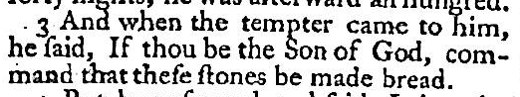
Archive.org | KJV 1611 First edition | - Exodus 23:23  - Capital “A”, no extra “and”  - 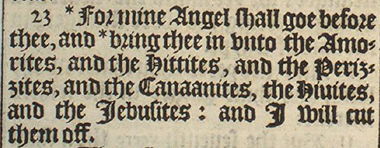  - Mat 4:1  - “Spirit”  - Mat 4:3  - “sonne of God”  - 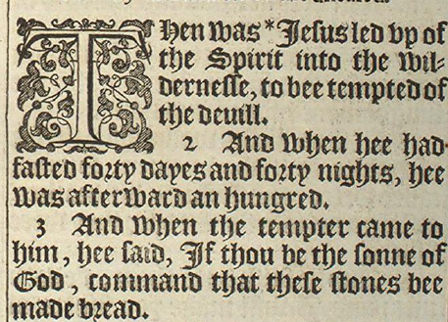  - Mark 1:12  - “Spirit”  - 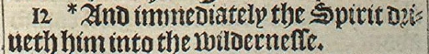  - Luke 4:1  - “spirit”  - 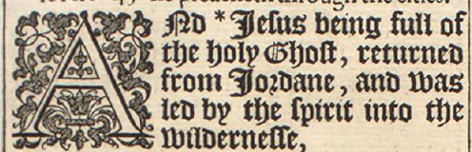  - Acts 11:12  - “spirit”  - 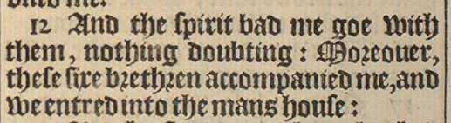  - Acts 11:28  - “spirit”  - 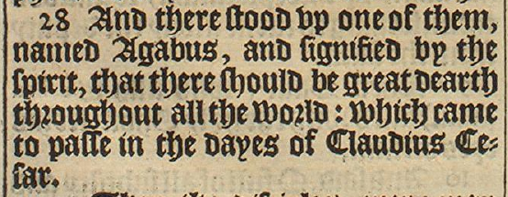  - 1 John 5:8  - “Spirit”  - 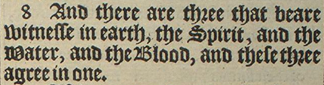
Archive.org | The Bible  Imprinted at London by Robert Barker, Printer to the Kings most excellent majesty  1616 | - Exodus 23:23  - Capital “A”, no extra “and”, “in” removed from before “unto”  - 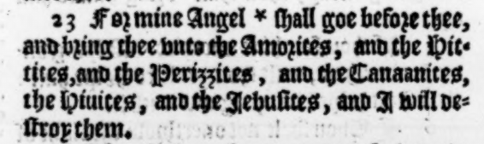  - Matthew 4:1  - “Spirit”  - Matthew 4:3  - “Sonne of God”  - 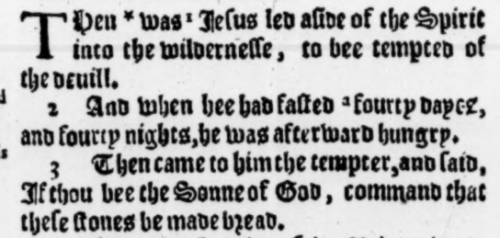  - Mark 1:12  - “spirit”  - 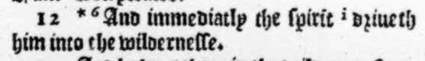  - Luke 4:1  - “Spirit”  - 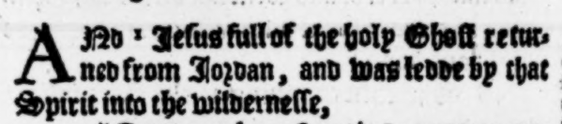  - Acts 11:12  - “Spirit”  - 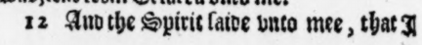  - Acts 11:28  - “Spirit”  - 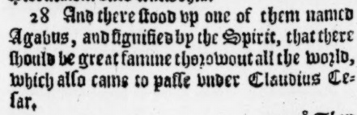  - 1 John 5:8  - “spirit”  - 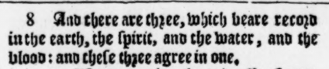
Jireh Independent Baptist Church | Printed Bible  Collins world  “Authorised King James Version”  printed in Great Britain | - Exo 23:23  - extra “and”  - 1Jno 5:8  - “spirit”

No extra “and” in Exo 23:23 | Extra “and” in Exo 23:23 (PCE)
Exodus 23:23  For mine Angel shall go before thee, and bring thee in unto the Amorites, and the Hittites, and the Perizzites, and the Canaanites, the Hivites, and the Jebusites: and I will cut them off. | Exodus 23:23  For mine Angel shall go before thee, and bring thee in unto the Amorites, and the Hittites, and the Perizzites, and the Canaanites, and the Hivites, and the Jebusites: and I will cut them off.
Jeremiah 32:5  And he shall lead Zedekiah to Babylon, and there shall he be until I visit him, saith the LORD: though ye fight with the Chaldeans, ye shall not prosper. | Jeremiah 32:5  And he shall lead Zedekiah to Babylon, and there shall he be until I visit him, saith the LORD: though ye fight with the Chaldeans, ye shall not prosper?
Mark 2:1  And again he entered into Capernaum after some days; and it was noised that he was in the house. | Mark 2:1  And again he entered into Capernaum, after some days; and it was noised that he was in the house.
Acts 11:12  And the Spirit bade me go with them, nothing doubting. Moreover these six brethren accompanied me, and we entered into the man’s house: | Acts 11:12  And the spirit bade me go with them, nothing doubting. Moreover these six brethren accompanied me, and we entered into the man’s house:
Acts 11:28  And there stood up one of them named Agabus, and signified by the Spirit that there should be great dearth throughout all the world: which came to pass in the days of Claudius Cæsar. | Acts 11:28  And there stood up one of them named Agabus, and signified by the spirit that there should be great dearth throughout all the world: which came to pass in the days of Claudius Cæsar.
1 Corinthians 15:27  For he hath put all things under his feet. But when he saith all things are put under him, it is manifest that he is excepted, which did put all things under him. | 1 Corinthians 15:27  For he hath put all things under his feet. But when he saith, all things are put under him, it is manifest that he is excepted, which did put all things under him.
1 John 5:8  And there are three that bear witness in earth, the Spirit, and the water, and the blood: and these three agree in one. | 1 John 5:8  And there are three that bear witness in earth, the spirit, and the water, and the blood: and these three agree in one.

Verse | Bibleanalyzer  av1769 | Archive.org  KJV | Holy Bible King James version (printed)  Christian Art Publishers | The Holy Bible (printed)  Authorized (King James) Version  Gideons International 1974 edition
Joshua 19:19 | Hapharaim | Haphraim | Hapharaim | Haph-rá-im
1Ch 2:47 | Geshan | Gesham | Geshan | Gé-sham
1Ch 2:49 | Achsah | Achsa | Achsah | Ach́-sa
1Ch 7:19 | Shemida | Shemidah | Shemida | She-mÍ-dah
2Ch 2:16 | floats | flotes | floats | flotes
Jer 2:22 | soap | sope | soap | sope
Mal 3:2 | soap | sope | soap | soap

